Calling OCS Webservice Using Dynamic Proxy

Contents

Dynamic Proxies Introduction: 2

How to build a Dynamic proxy: 2

1. Define the variables 2

2. Define the Payload 2

3. Put it together and execute the request 3

4. Helper functions 3

# Dynamic Proxies Introduction:

## Compile nothing at development time, all resolved at runtime

## Application retrieves WSDL, dynamically constructs calls

## More complex to develop

## Able to manage customizations and dynamicity in WSDL

## More robust for production use

# 

# How to build a Dynamic proxy:

## Define the variables

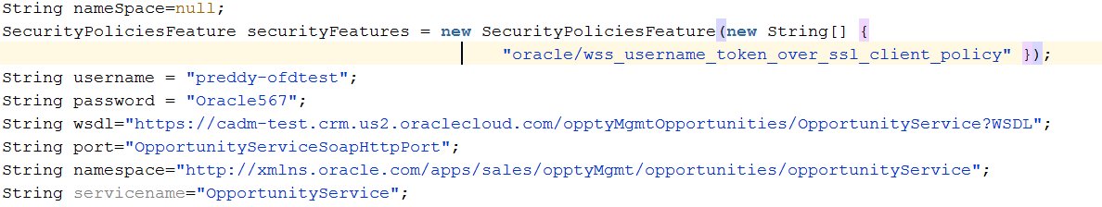

## Define the Payload

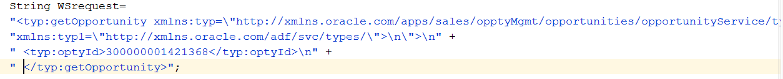

## Put it together and execute the request

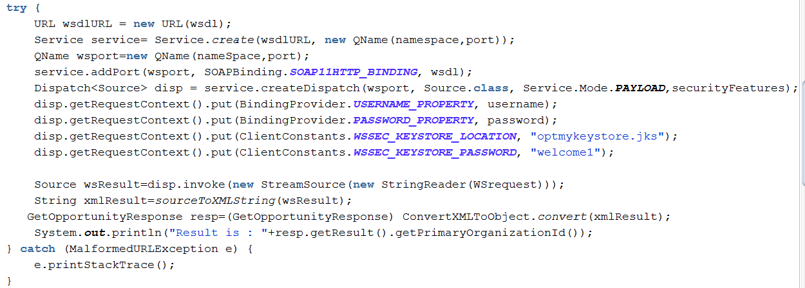

## Helper functions

